

A Project Report

On

**“Customer Support Chatbot using AI with ML”**

Batch Details

|  |  |  |
| --- | --- | --- |
| Sl. No. | Roll Number | Student Name |
| 1 | 20211CSE0036 | KOLIMI JAHNAVI |
| 2 | 20211CSE0136 | TATICHERLA VARSHA |
| 3 | 20211CSE0027 | SADDALA HARSHITHA |
| 4 | 20211CSE0038 | R GAGANA SHREE |
|  |  |  |

**School of Computer Science,**

**Presidency University, Bengaluru.**

Under the guidance of,

Dr. Hassan Hussain S , Professor

School of Computer Science,

Presidency University, Bengaluru

**Introduction About the Project :**

In an era where customer expectations for fast, efficient service are rising, traditional support methods struggle to keep up. Our project introduces an **AI-powered Customer Support Chatbot** that leverages **Machine Learning (ML)** and **Natural Language Processing (NLP)** to revolutionize customer interaction. Designed to address repetitive inquiries, it allows customer support teams to focus on complex queries. This chatbot uses advanced language understanding to interpret user intent, learn from interactions, and provide relevant responses, ensuring users receive accurate support at any hour. With 24/7 availability and the ability to handle high volumes of requests, this solution not only improves customer satisfaction but also optimizes company resources, minimizing the reliance on human agents for routine queries.

* **Automated Query Resolution**: Rapid response to common questions
* **Database Search and Resolution Matching**: Pulls answers from a knowledge base
* **Human Handover**: Escalates complex issues to human agents
* **Continuous Learning**: Improves accuracy and personalization over time

**Literature Review :**

|  |  |  |  |  |
| --- | --- | --- | --- | --- |
| **S .No** | **Paper Name** | **Author Name** | **Advantages** | **Dis advantages** |
| **1.** | **A Systematic Review of Recent Research on Chatbots** | **IEEE researchers** | **Comprehensive review of advancements in chatbot design and deployment​** | **Limited focus on domain-specific applications, providing a more general overview.** |
| **2.** | **The Use of Chatbots in Digital Business Transformation: A Systematic Literature Review** | **IEEE researchers** | **Highlights the role of chatbots in business efficiency and customer interaction​** | **Limited exploration of security challenges in digital transformations involving chatbots.** |
| **3.** | **Conversational Agents in Healthcare** | **Milena Vasilevskiy and Michael F. Melchner** | **Focuses on chatbots in healthcare, emphasizing patient engagement and education.** | **Lacks quantitative assessment of chatbot performance in complex medical queries.** |
| **4.** | **Emotional Intelligence in Chatbots: A Survey** | **Yuko Matsuda and Hiroshi Sato** | **Discusses the integration of emotional responses for more natural interactions.** | **Limited applicability to task-oriented bots that do not require emotional processing.** |
| **5.** | **Educational Chatbots: Enhancing Student Learning** | **Rina Abdul and Sameer Das** | **Examines chatbot effectiveness in boosting student engagement and personalized learning.** | **Findings are primarily applicable to academic settings, with limited generalizability.** |
| **6.** | **AI-Driven Conversational Interfaces: Challenges and Future Directions** | **Li Min and Olga Ivanova** | **Provides a forward-looking analysis of AI in conversational agents and potential advancements.** | **Focuses heavily on theoretical aspects with fewer real-world case studies.** |

**Objectives:**

Following are some of our objectives:

1. The chatbot will be build using machine learning

2. Data base to complete the customer need

3. All modules used to develop the bot should work synchronously.

4. The interactions between the user and the chatbot should be fast.

5. Store User related details such as Name, Phone number, Account ID.

6. Preprocess of the queries given by customer.

**EXPERIMENTAL DETAILS/METHDOLOGY :**

**Frontend:**

1. React.js
2. HTML, CSS
3. JavaScript

**Backend:**

1. Node.js with Express.js
2. Python/Django

**Database:**

1. MongoDB/MySQL
2. Firebase

**METHODOLOGY:**

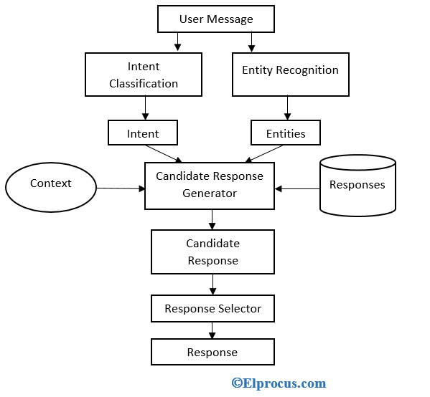

**OUTCOMES :**

1. **Improved Response Time:** The chatbot can provide immediate responses to customer inquiries, significantly reducing wait times compared to traditional support channels. This leads to higher customer satisfaction and retention.
2. **24/7 Availability:** The chatbot operates around the clock, allowing customers to get assistance at any time, even outside of regular business hours. This increases accessibility and can lead to higher engagement.
3. **Consistent Responses:** The AI ensures that all customers receive consistent and accurate information, reducing the chances of miscommunication and providing a reliable source of information.
4. **Efficient Query Handling:** The chatbot can handle a high volume of inquiries simultaneously, which helps manage peak times without overwhelming human agents. This efficiency can lead to cost savings for businesses.
5. **Data-Driven Insights:** By analysing customer interactions, the chatbot can gather valuable data on customer preferences, common issues, and overall sentiment. This information can be used to improve products and services and enhance customer experience.

**6.Seamless Escalation to Human Agents:** For complex inquiries, the chatbot can smoothly escalate issues to human agents, providing them with context from the previous interactions. This ensures that customers receive personalized and effective support when needed.

**6. TIMELINE OF THE PROJECT/ PROJECT EXECUTION PLAN**

**CONCLUSION**

In summary, the deployment of an AI and ML-driven customer support chatbot has the potential to revolutionize the customer service landscape. This project illustrates how such technology can enhance customer interactions by providing immediate assistance, reducing response times, and ensuring 24/7 availability.

By streamlining the query handling process, the chatbot not only improves operational efficiency but also allows human agents to focus on more complex issues, thereby optimizing resource allocation. The data insights gained from user interactions can inform business strategies, driving improvements in products and services based on customer feedback.

Ultimately, this project underscores the importance of embracing innovative solutions to meet evolving customer expectations. The chatbot serves as a powerful tool for fostering engagement, increasing satisfaction, and building long-term loyalty, paving the way for a more responsive and customer-centric approach in the digital age.

**References :**

2002. A.L.I.C.E. Foundation website. (2002). Retrieved January 4, 2017 from [http://alicebot.org](http://alicebot.org/)

2013. Mitsuko. (2013). Retrieved January 4, 2017 from [http://www.mitsuku.com](http://www.mitsuku.com/)

2013. Rose. (2013). Retrieved January 4, 2017 from <http://brilligunderstanding.com/rosedemo.html>

2016. Facebook Messenger bots. (2016). Retrieved Dec 1, 2016 from <https://chatbottle.co/bots/messenger>

2017. Facebook Messenger Alterra. (2017). Retrieved January 30, 2017 from <https://www.messenger.com/t/alterra.cc>

“Chatbots in customer service: Their relevance and impact on service quality” , Chiara Valentina Mis ischia, Flora Pouce, Christine Strauss,

[ScienceDirect](https://www.sciencedirect.com/science/article/pii/S1877050922004689).

“Chatbots: History, technology, and applications.” Machine Learning with Applications, 2 (100006) (2020),[Google scholar](https://scholar.google.com/scholar_lookup?title=Chatbots%3A%20History%2C%20technology%2C%20and%20applications.&publication_year=2020&author=Eleni%20Adamopoulou&author=Lefteris%20Moussiades)

“Chatbots – An Interactive Technology for Personalized Communication, Transactions and Services.”IADIS International Journal on WWW/Internet, 15 (1) (2017), pp. 96-109, [Google scholar](https://scholar.google.com/scholar_lookup?title=Chatbots%20%20An%20Interactive%20Technology%20for%20Personalized%20Communication%2C%20Transactions%20and%20Services.&publication_year=2017&author=Darius%20Zumstein&author=Sophie%20Hundertmark)

How to create a chatbot with google dialog flow (2020), [MEDIUM](https://cobusgreyling.medium.com/how-to-create-a-chatbot-with-google-dialogflow-60616c2b802f)

“A conversation-based perspective for shaping ethical human-machine interactions: The particular challenge of chatbots. Journal of Business Research, 129 (2021), pp. 927-935 ,[Google scholar](https://scholar.google.com/scholar_lookup?title=A%20conversation-based%20perspective%20for%20shaping%20ethical%20human-machine%20interactions%3A%20The%20particular%20challenge%20of%20chatbots.&publication_year=2021&author=Grazia%20Murtarelli&author=Anne%20Gregory&author=Stefania%20Romenti)